Saurav Shrestha

[company name]

Admin(Oracle) Guideline

Organocity

Admin(Oracle) Guidelines

1. Login from the User Login section is needed initially to login to the admin dashboard.

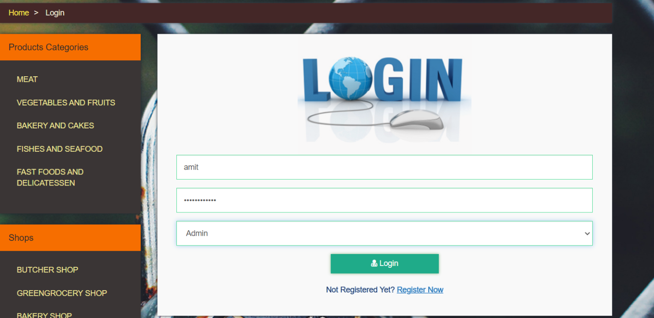

1. After User Login section, login from Oracle is done.

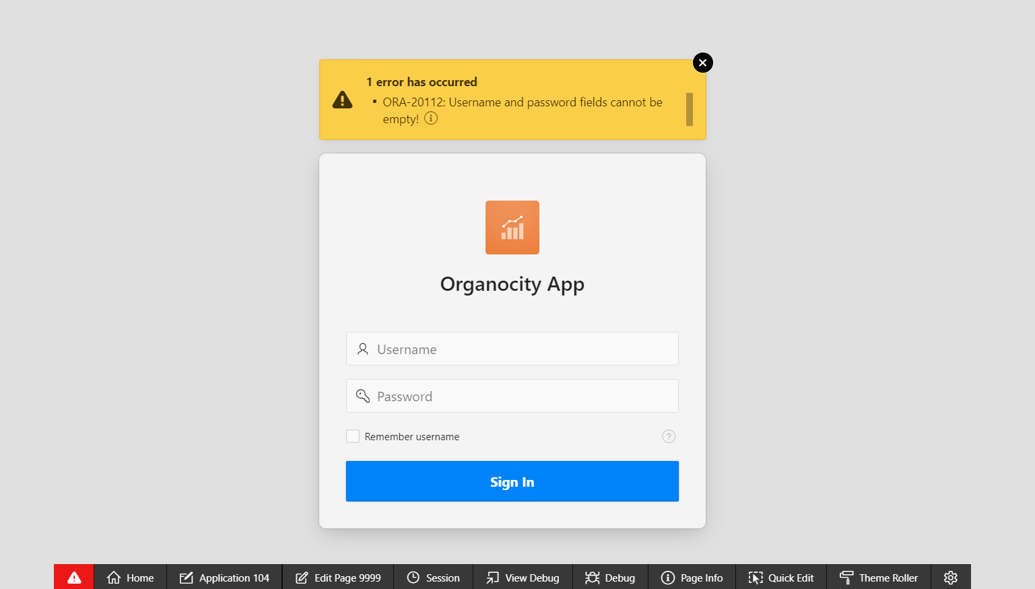

1. An error message is displayed if login is attempted without entering details.

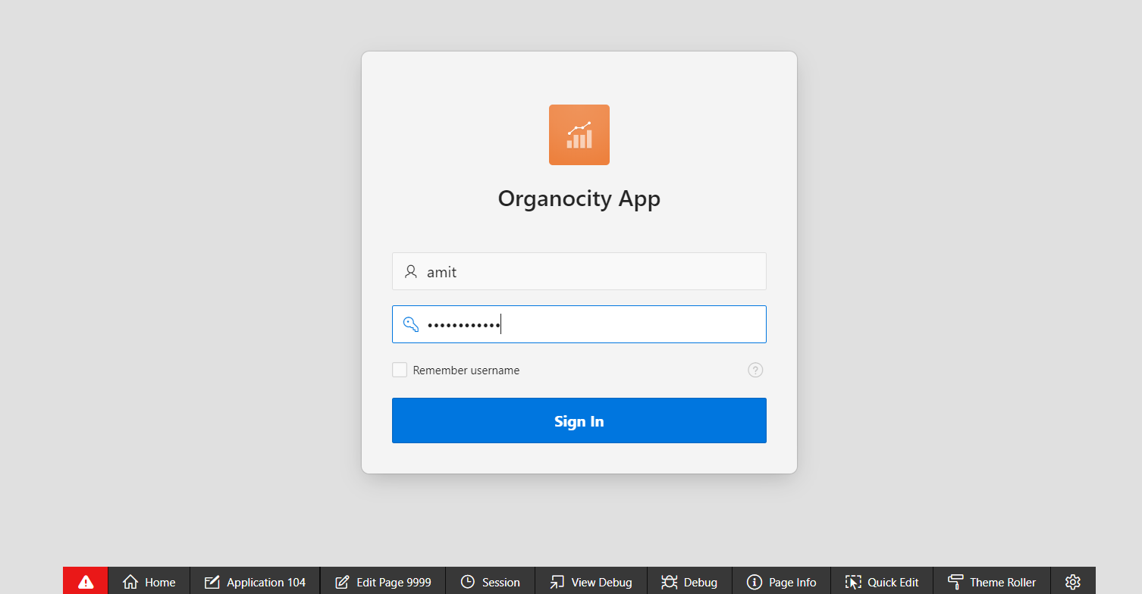

1. Error message is also displayed if an attempt to login is made with wrong credentials.

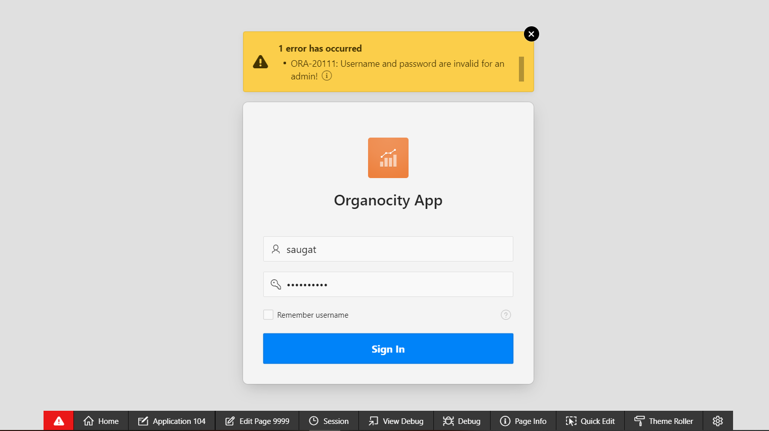

1. Login is possible only of appropriate credentials are provided.
2. After login, the user is redirected to the admin dashboard.

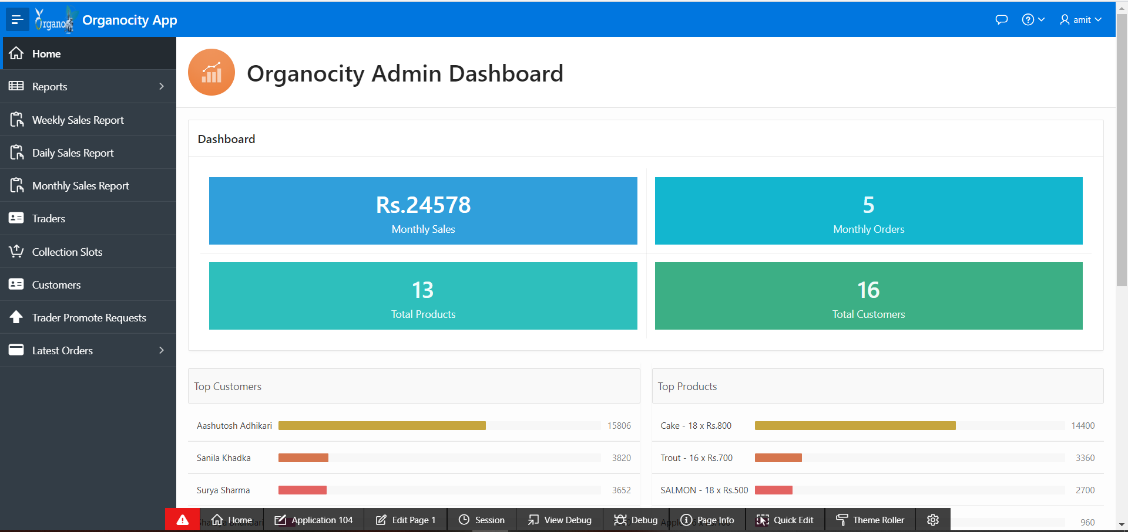

1. The dashboard has details related to total sales, sales per trader and more.

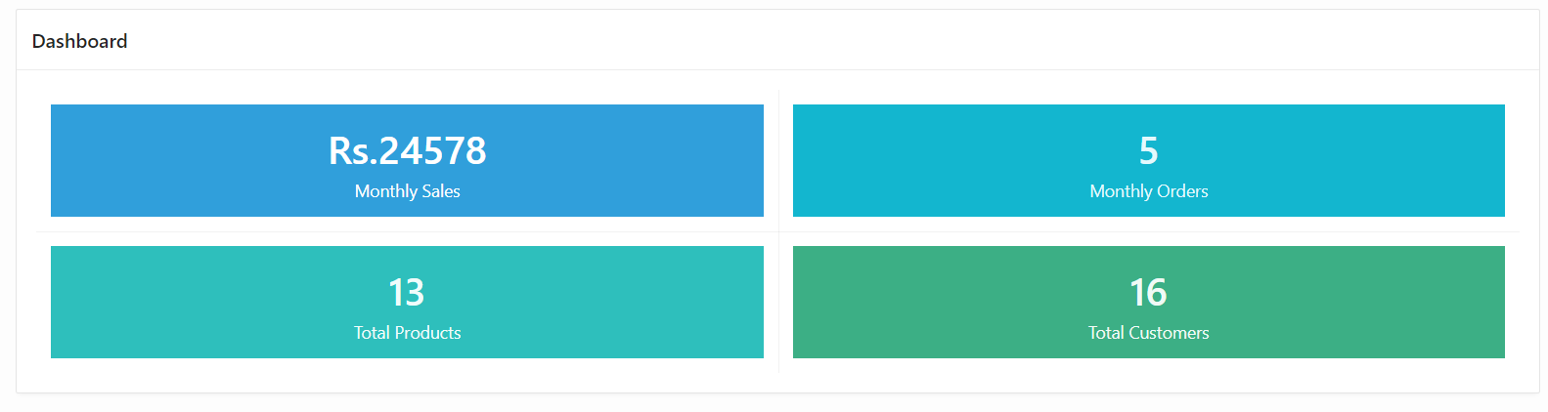

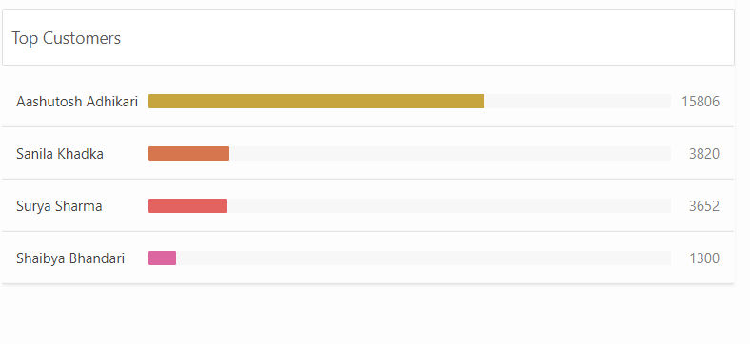

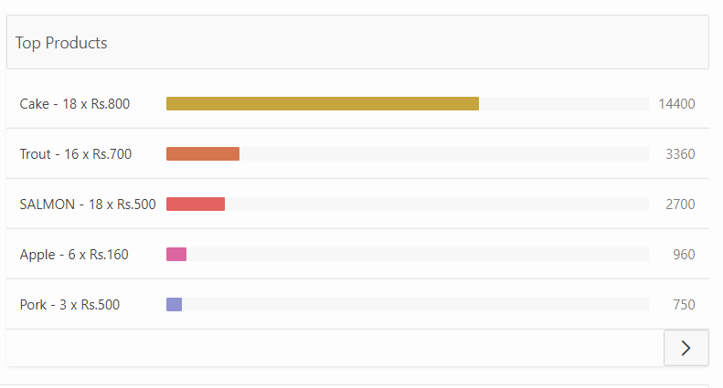

1. Admins can view different reports on the products of shops, product categories, etc.

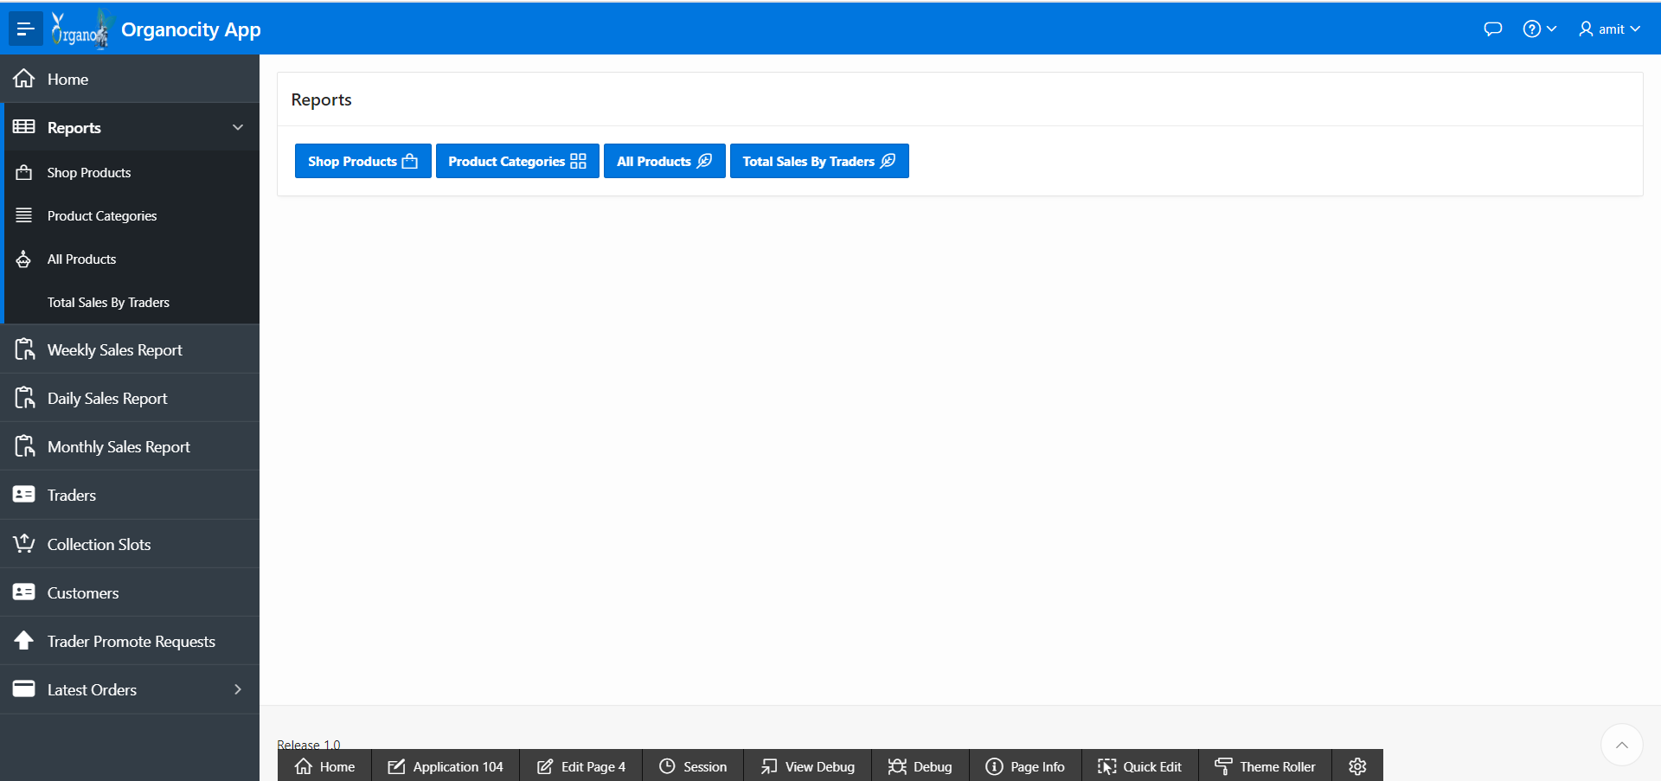

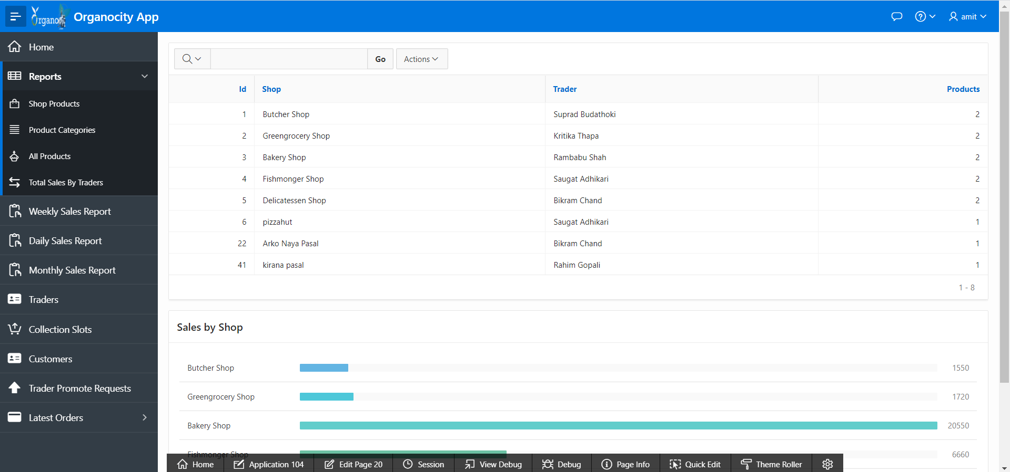

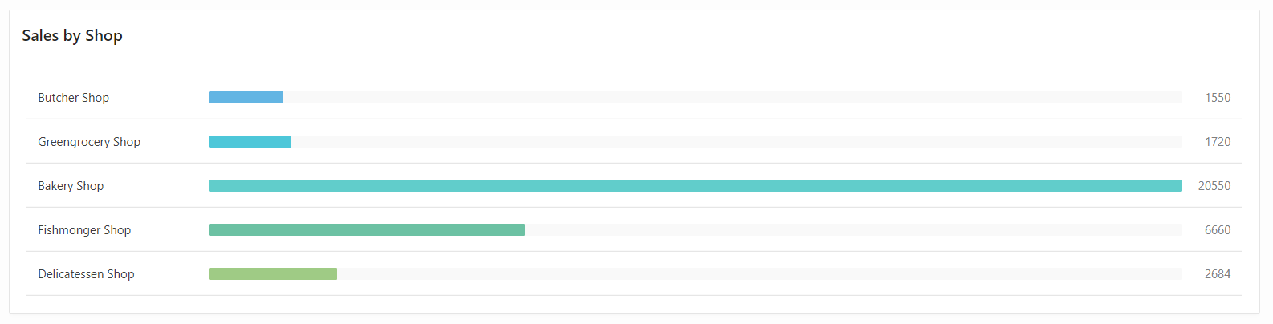

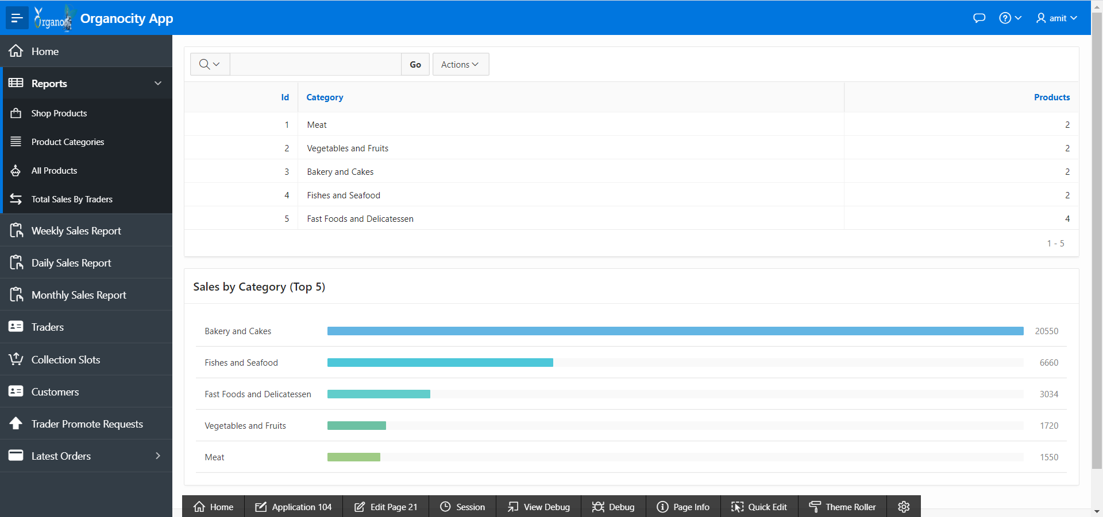

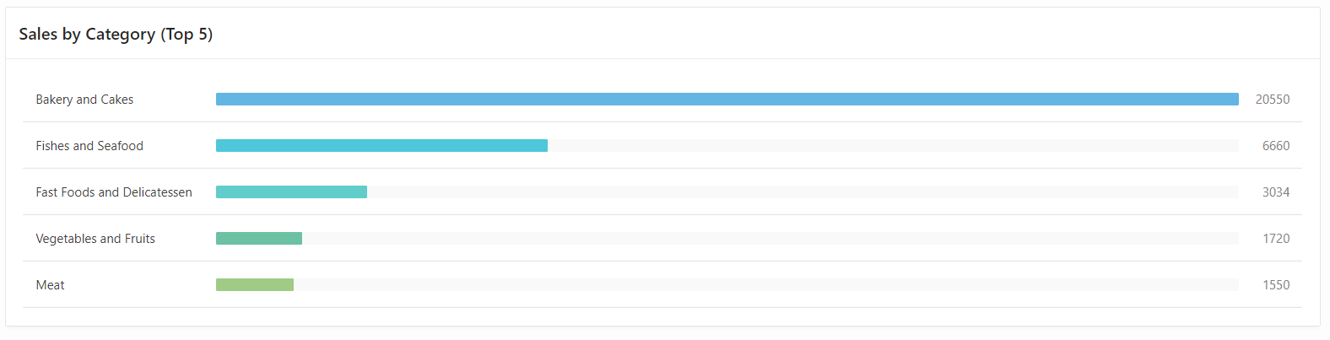

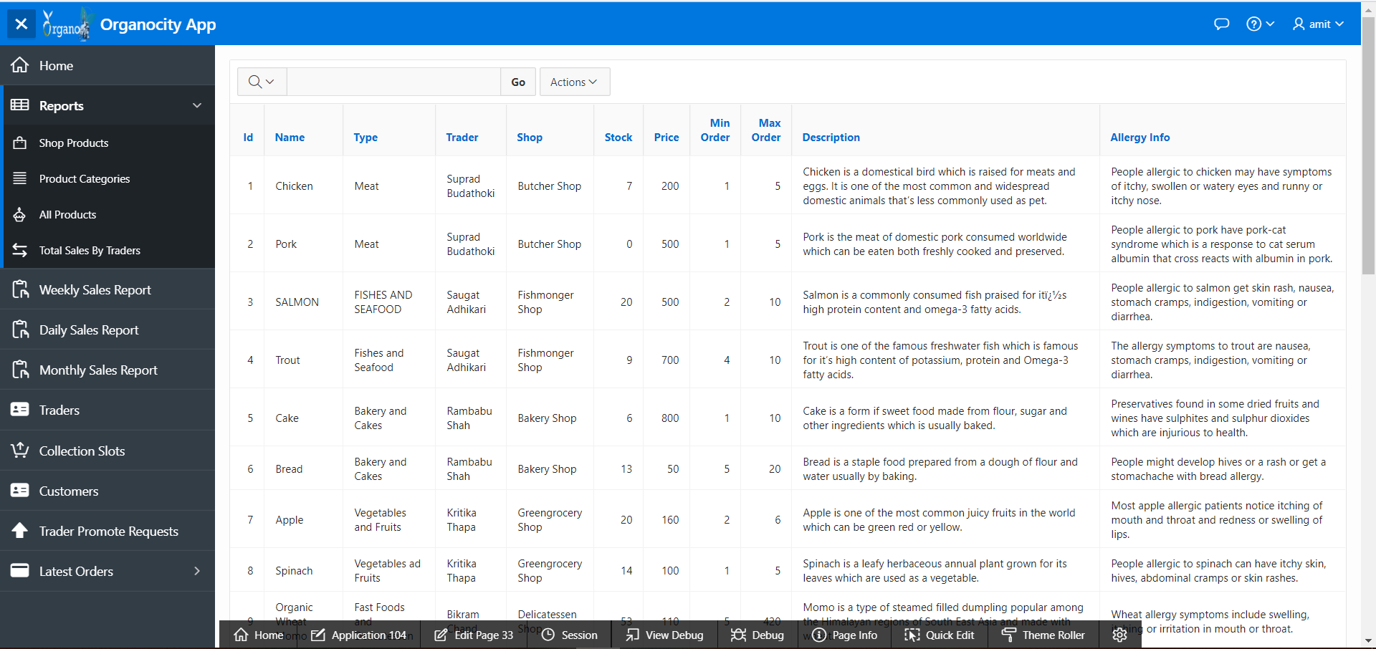

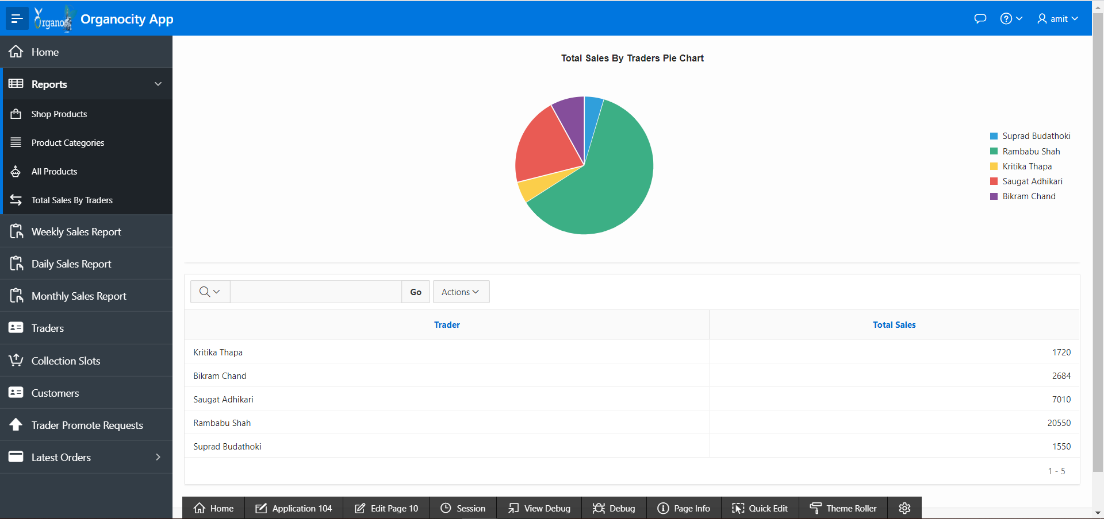

1. Admins can view Weekly Sales Reports of the different traders.

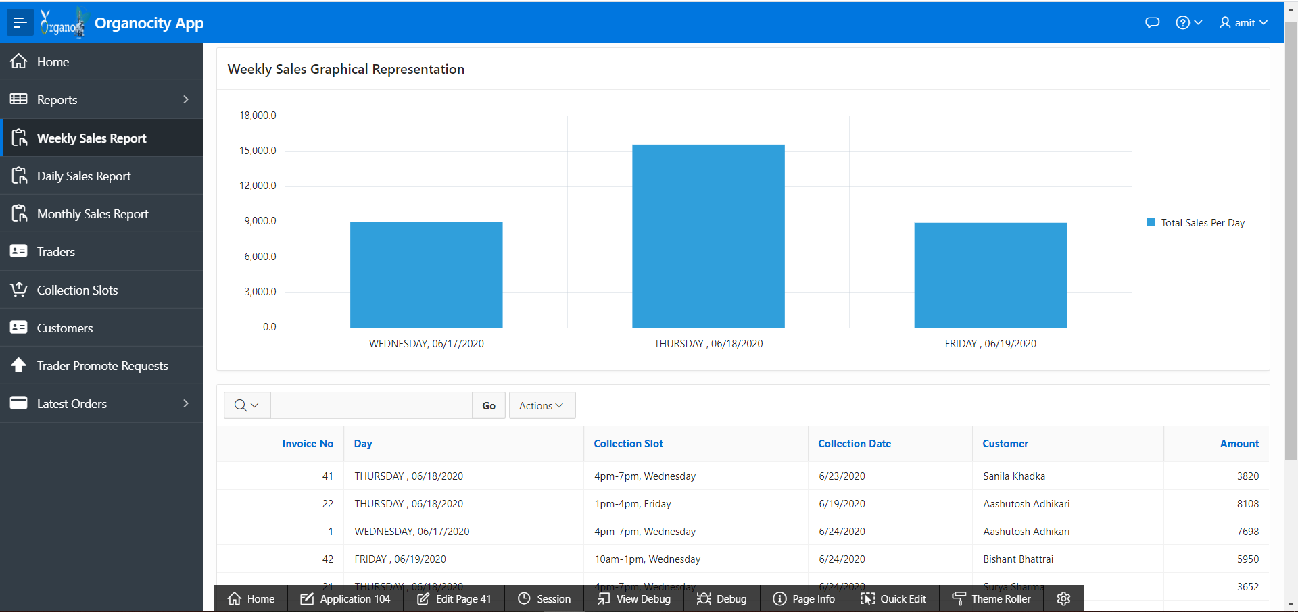

1. Admins can view Daily Sales Reports of the different traders.

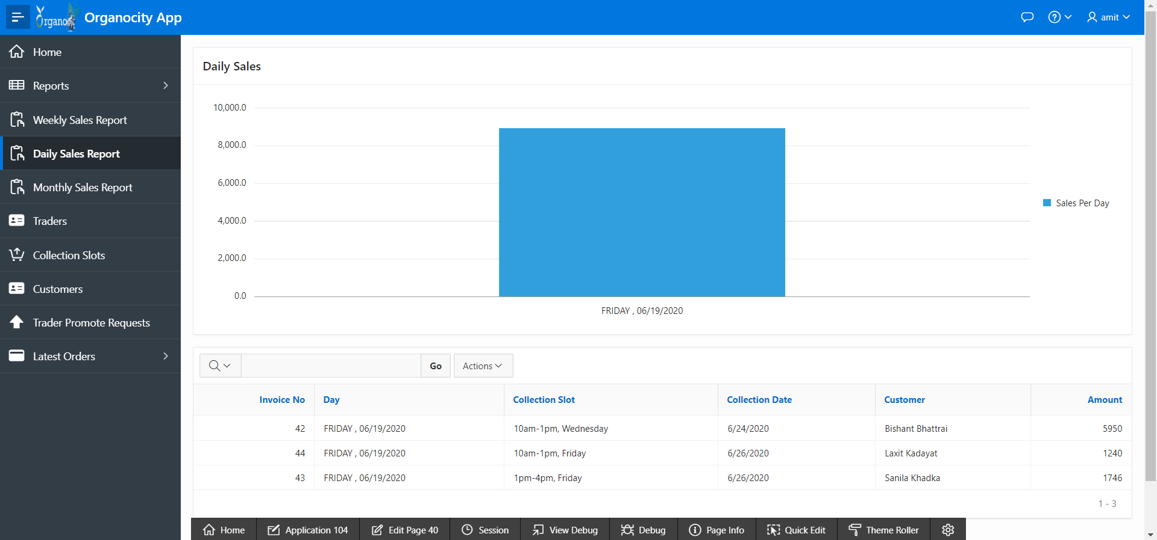

1. Admins can view Monthly Sales Reports of the different traders.

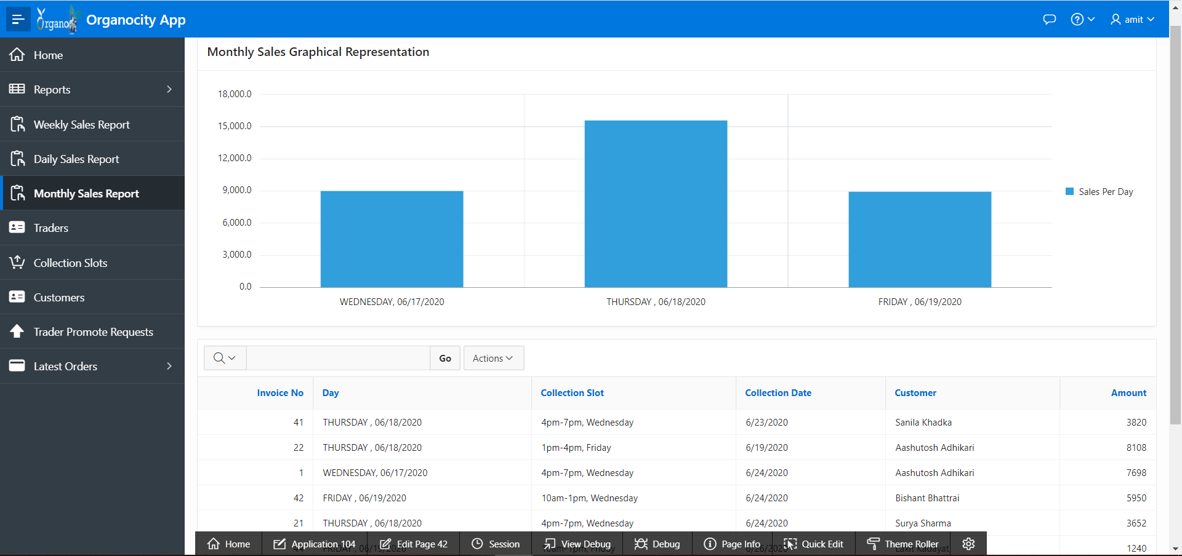

1. Admins can also view and interact with the profile of the traders.

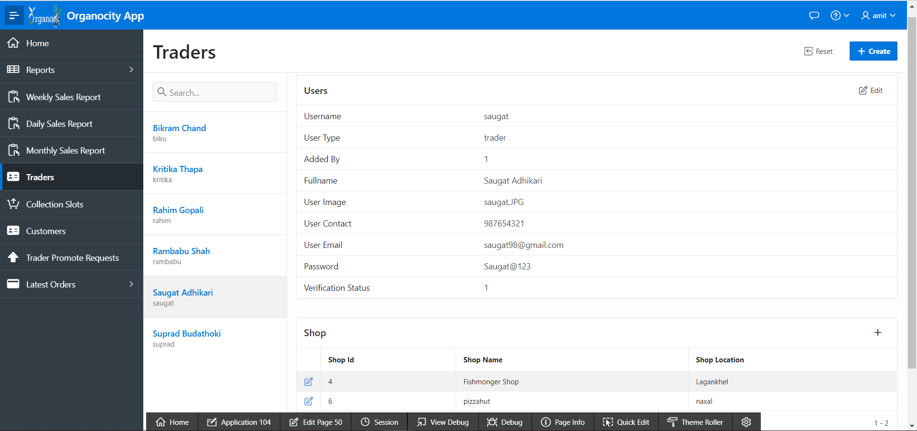

1. The availability of different collection slots can also be managed by the admin.

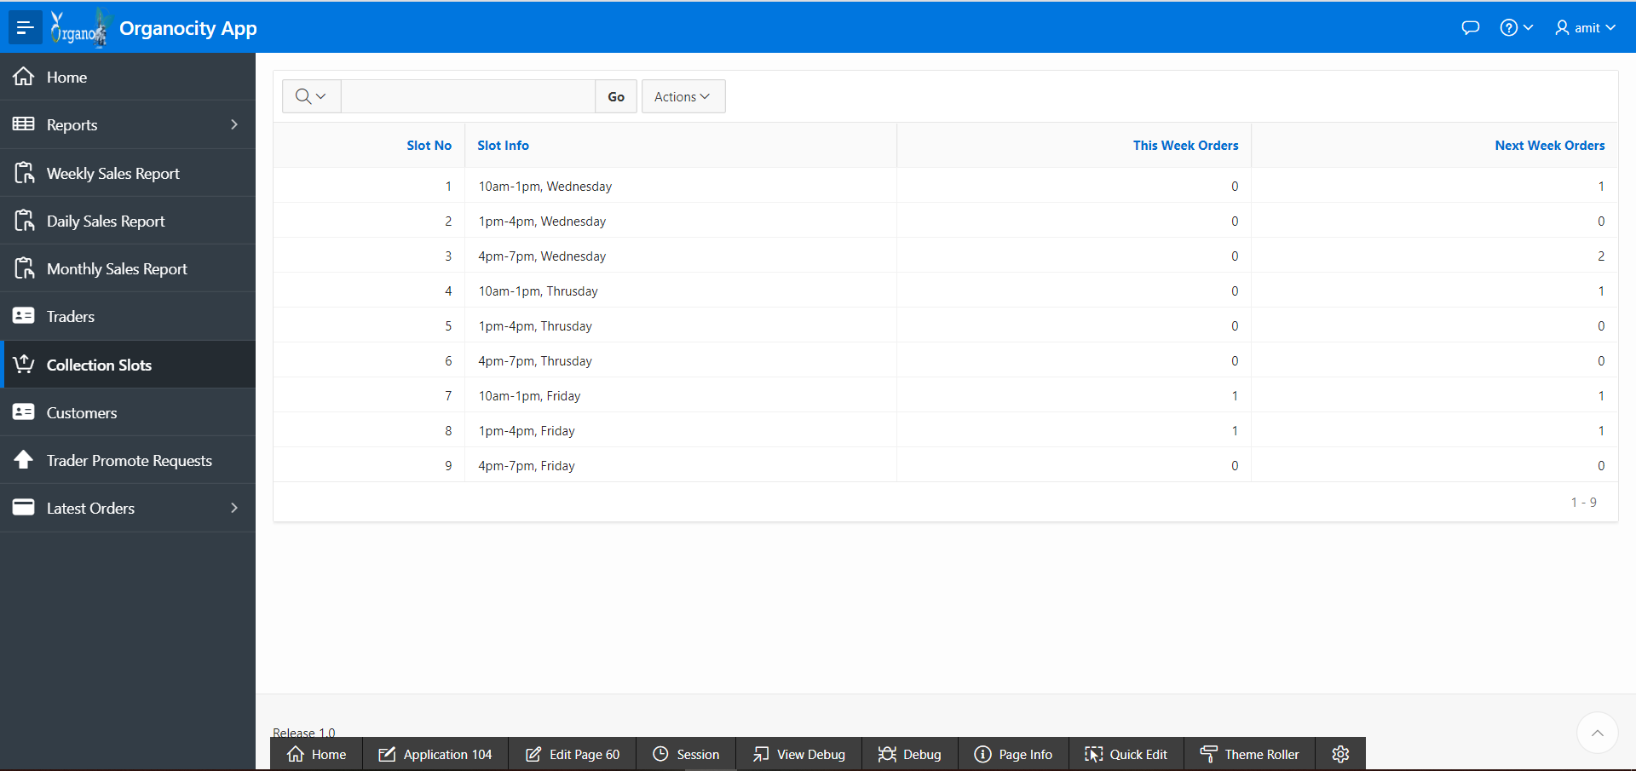

1. Customer profiles are also able to be edited by admins.

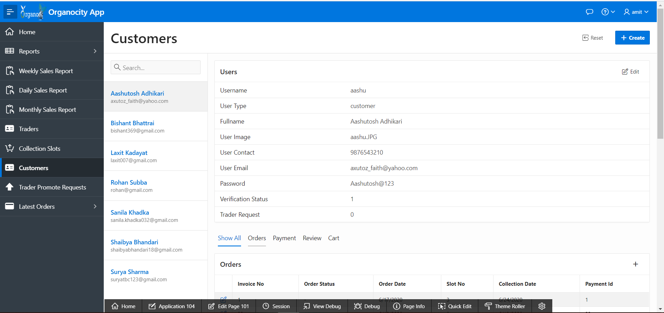

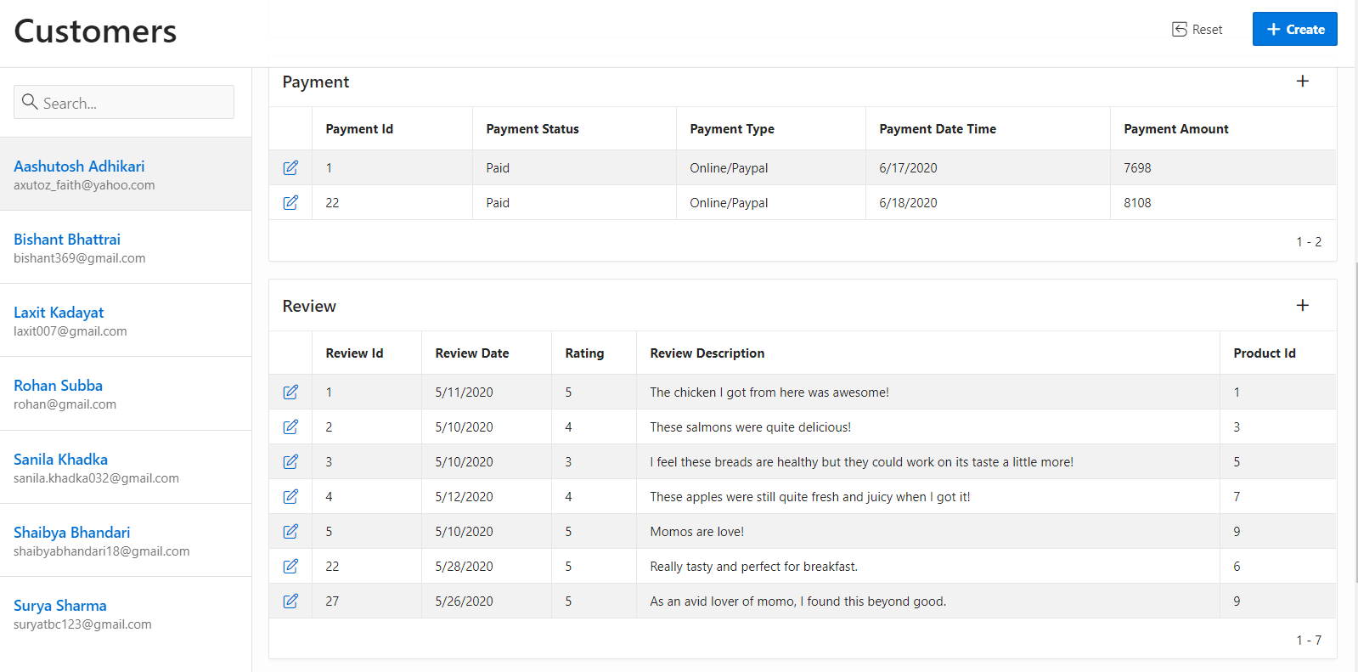

1. Order status and details can also be viewed by the admin.

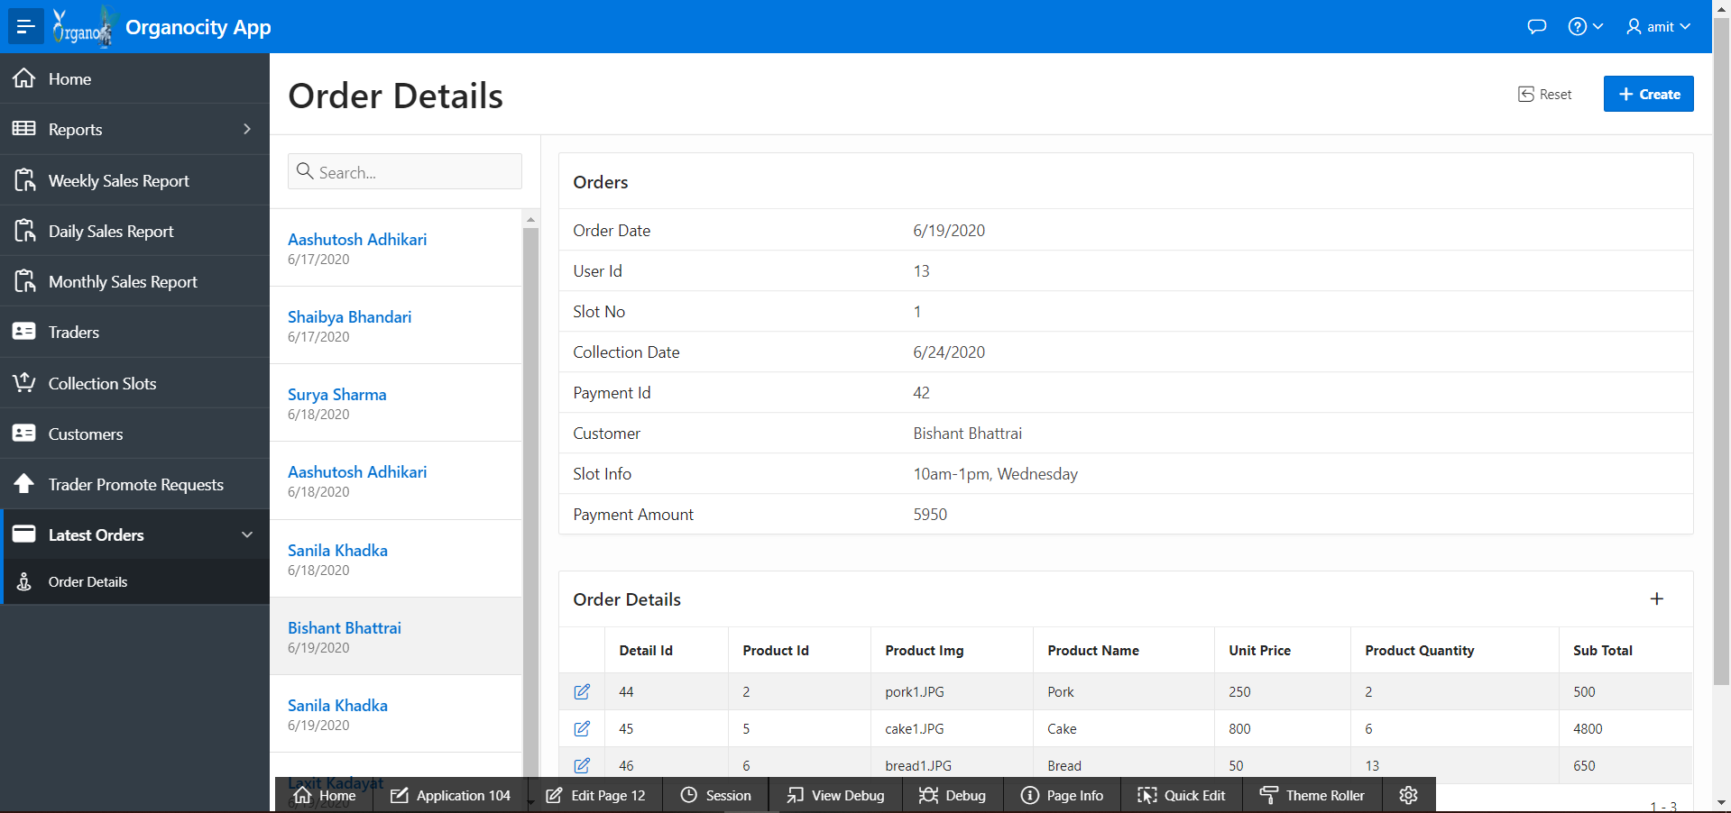

1. Admins also handle requests from regular users who wish to be a trader.

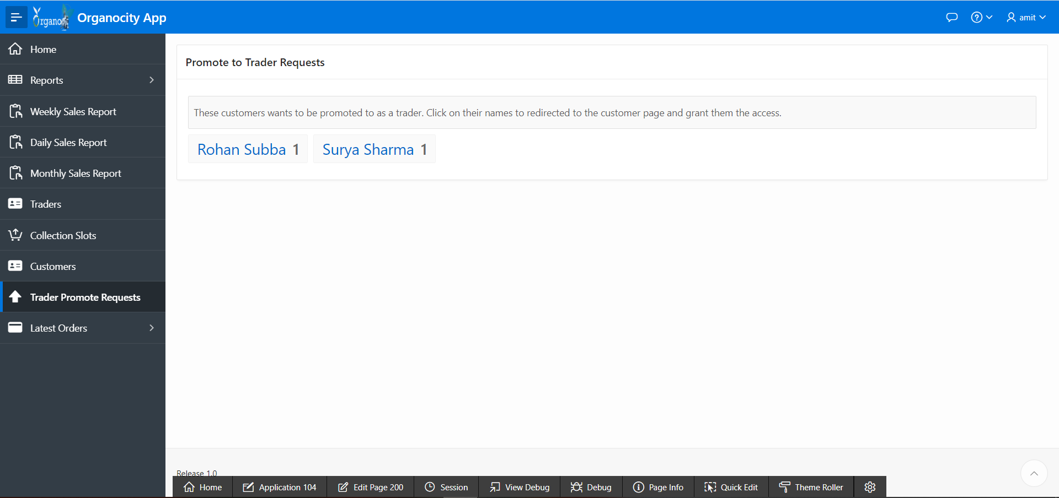

1. Admins also view the most recent orders made on different traders’ store.

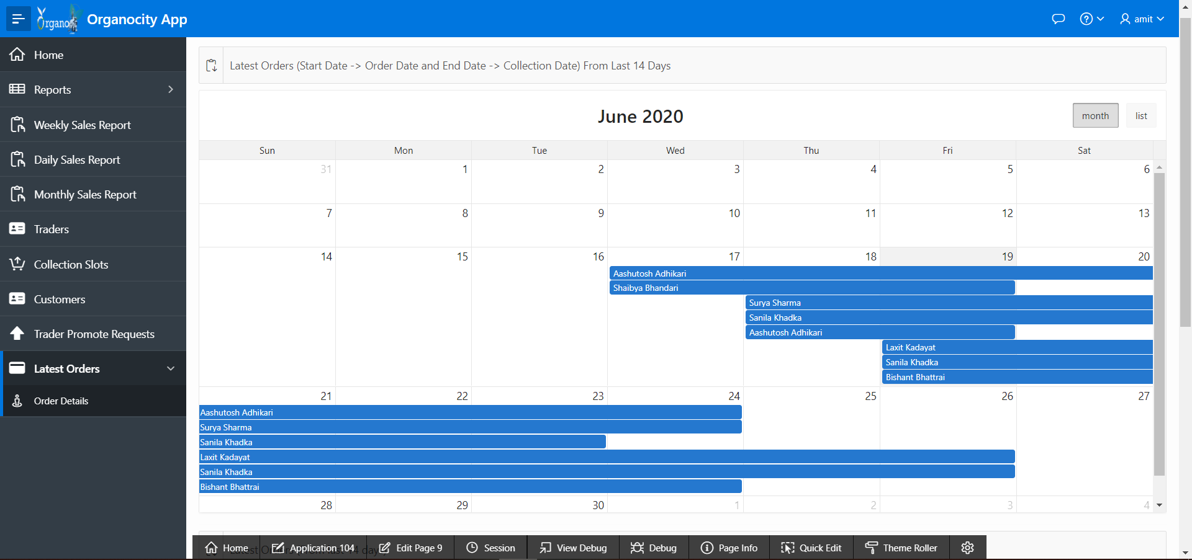

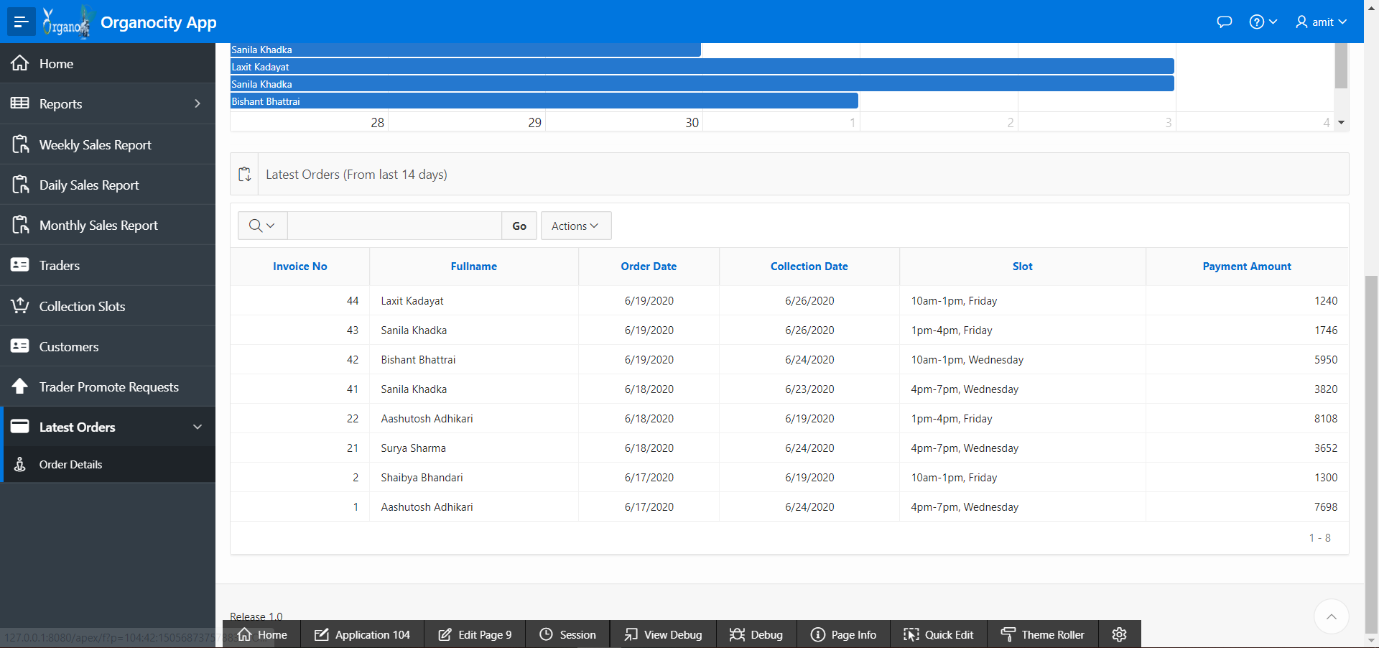

1. Different charts and graphs related to sales and stock are also available to the admins.

